Table of Contents
2.1 Landing Page 2
2.1.1 Introduction 2
2.1.2 Features 3
2.1.3 How It Works 3
2.1.4 Testimonials 3
2.2 Registration 4
2.3 Login 5
6. Glossary 6

Landing Page

Introduction
Our project, MyDiet, is a web-based application that helps users develop healthier eating habits. The landing page is the first page users see, and it introduces the main idea and functions of the system. 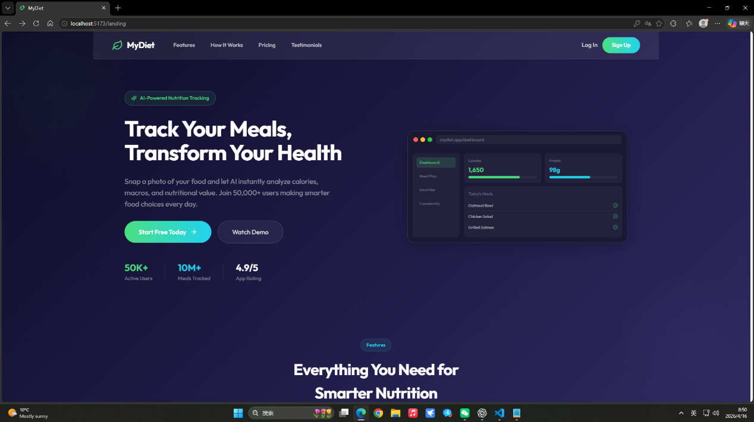
When users open the page, they see the main headline, “Track Your Meals, Transform Your Health,” which shows the purpose of the application. There is also a short description explaining that users can track their meals and get nutritional information more easily. A “Start Free Today” button is provided so users can begin using the system.
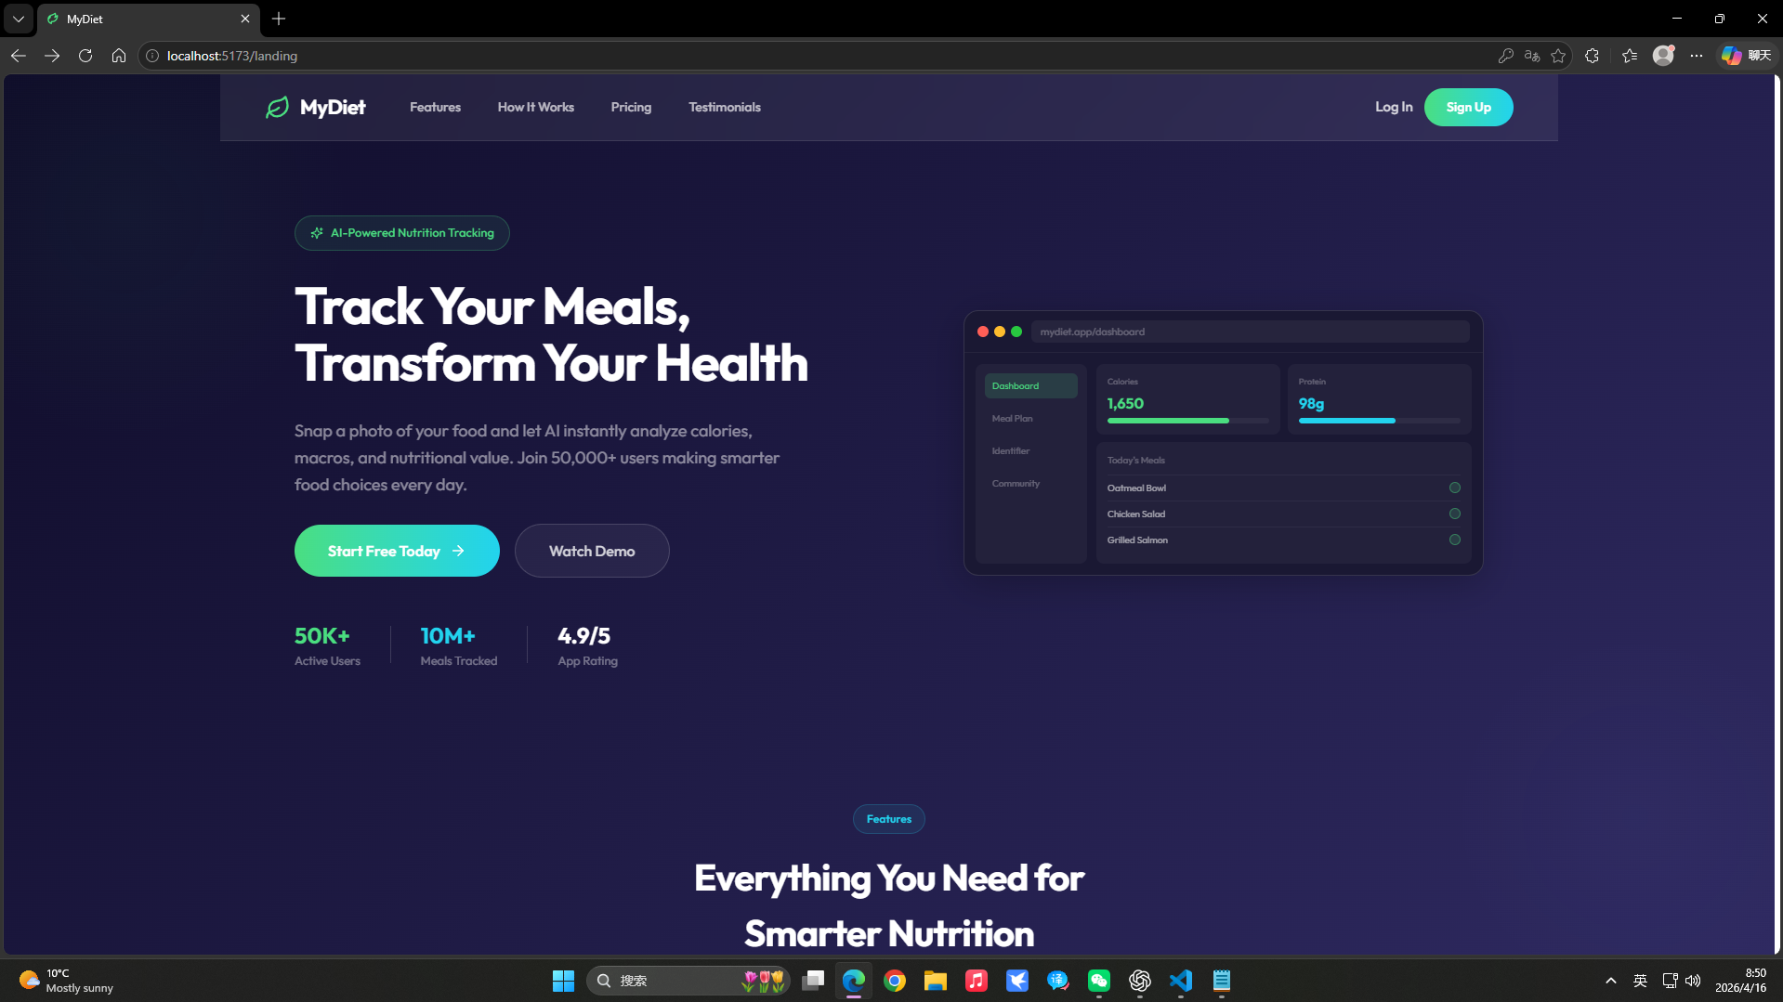
At the top of the page, there is a navigation bar with sections such as Features, How It Works, and Testimonials. When users click these items, the page scrolls down to the corresponding section instead of opening a new page.

Features
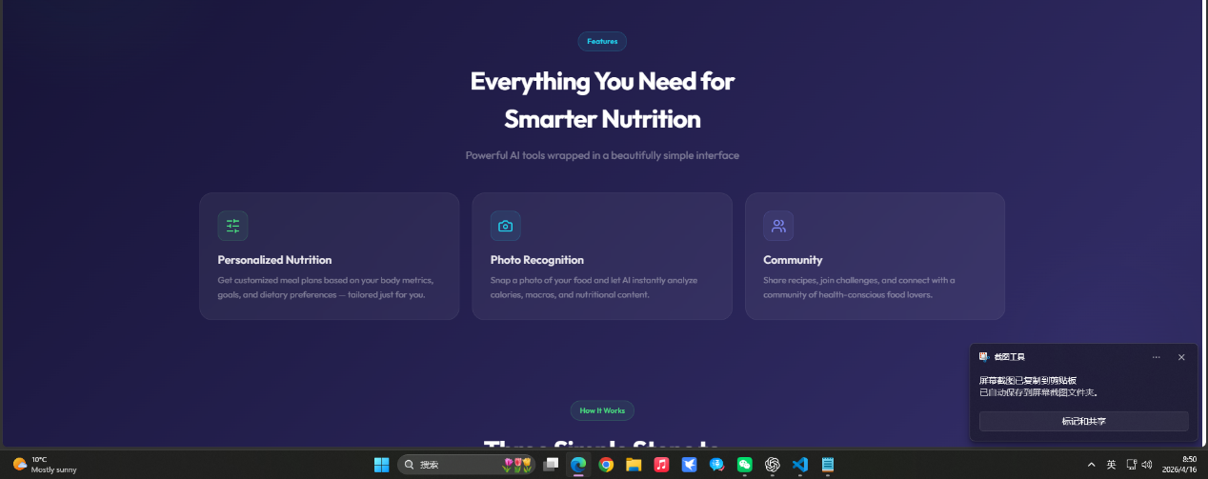
In the Features section, the system introduces its main functions. These include personalized nutrition plans, photo-based food tracking, and a community feature. The meal plans are generated using algorithms based on user information such as age, weight, and goals. The food tracking function uses AI to analyze meals from photos and estimate calories and nutrients. The community function mainly allows users to share their recipes and supports tracking other users, similar to following their favorite bloggers.

How It Works
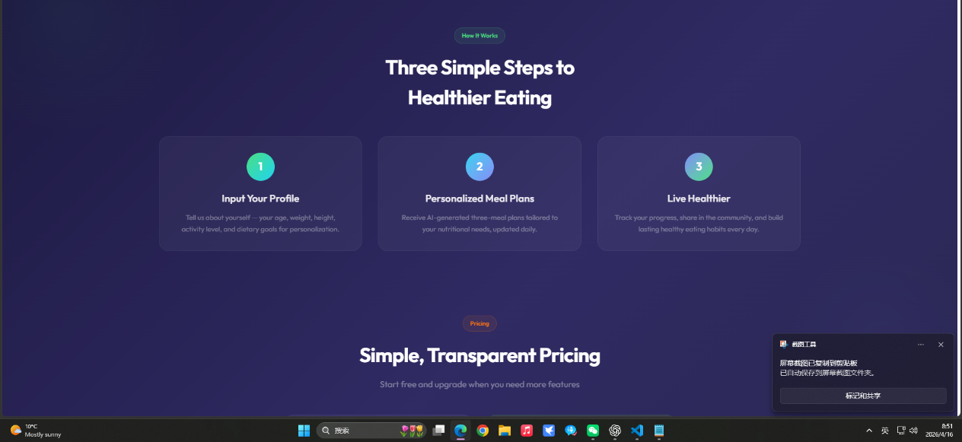

The How It Works section explains the process in three steps. First, users enter their personal information. Then, the system generates meal plans based on this data. Finally, users can track their progress and adjust their habits over time.


Testimonials
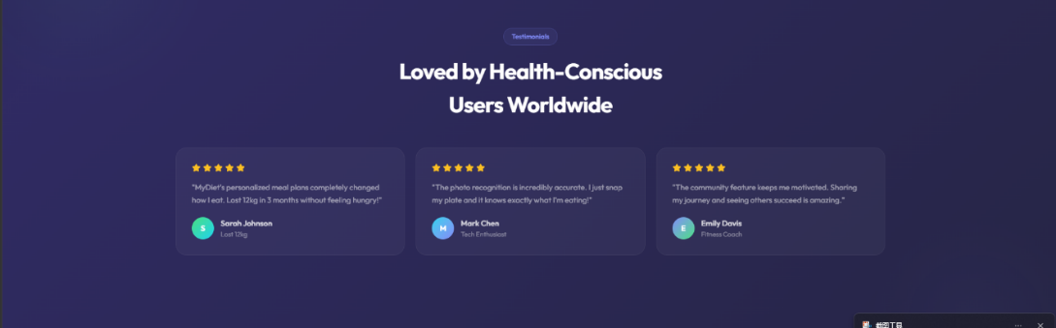
The Testimonials section shows feedback from users, including their experiences with weight management and diet improvement. This gives an idea of how the system can be used in practice.

Registration
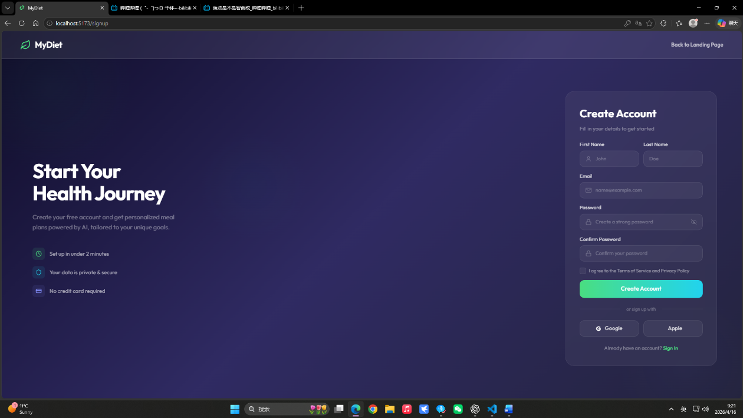
The registration page allows new users to create an account before using the system. The layout is simple, with a short introduction on the left and the sign-up form on the right.
Users are required to enter basic information, including first name, last name, email, and password. There is also a confirmation field for the password to reduce input errors. Before creating an account, users need to agree to the terms of service and privacy policy.
A “Create Account” button is provided to submit the form. In addition to the standard registration process, users can also sign up using third-party options such as Google or Apple, which makes the process faster.
On the top right corner, there is a “Back to Landing Page” option, allowing users to return to the main page. At the bottom of the form, there is also a link for users who already have an account to go to the login page.

Login
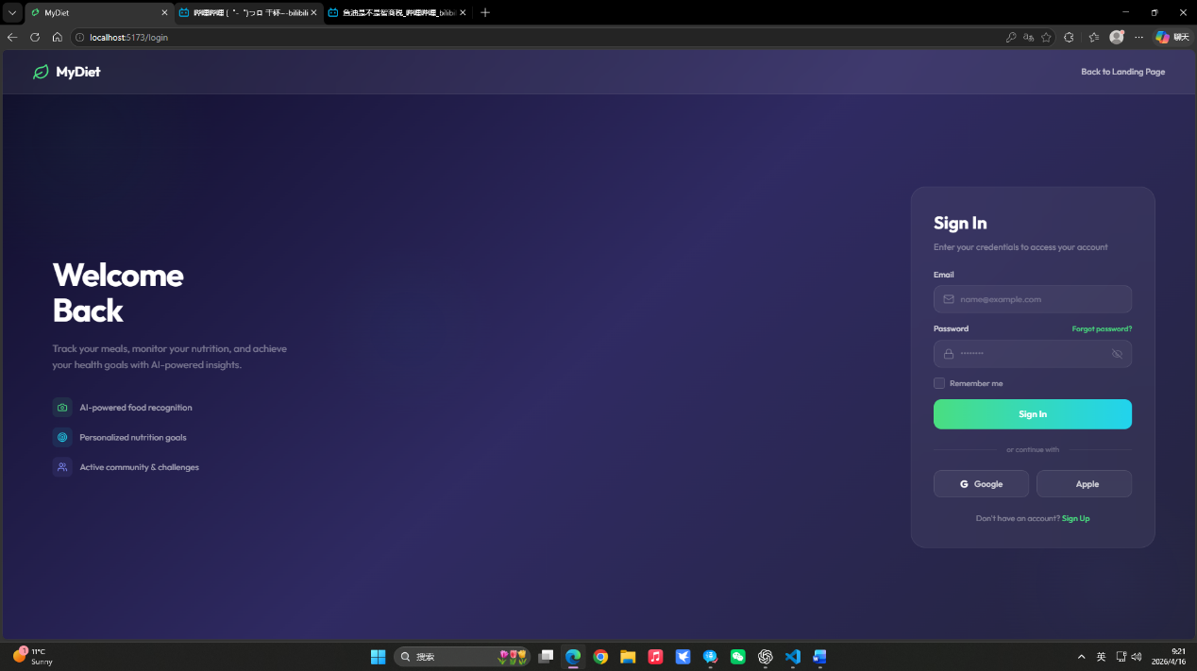The login page is designed for existing users to access their accounts. The structure is similar to the registration page, which keeps the experience consistent.
Users need to enter their email and password to sign in. There is also a “Remember me” option that allows users to stay logged in on the same device. If users forget their password, they can click the “Forgot password?” link for recovery.
A “Sign In” button is used to submit the login information. Similar to the registration page, users can also log in using Google or Apple accounts.
There is also a link for users who do not have an account yet, which directs them to the registration page. In addition, users can return to the landing page through the navigation option at the top.

6. Glossary
AI-based Food Recognition
A feature that uses artificial intelligence to identify food items from uploaded photos and estimate their nutritional content, such as calories and macronutrients.
Algorithm-based Personalization
A method that generates personalized meal plans based on user data such as age, weight, goals, and activity level, using predefined rules or algorithms.
User Authentication
The process of verifying a user’s identity through login credentials (such as email and password) before allowing access to the system.
Form Validation
A mechanism that checks whether user input meets required conditions (for example, correct email format or matching passwords) before the form is submitted.
Dashboard
A central page where users can view key information, such as daily calorie intake, nutrition progress, and meal tracking.
Drag-and-Drop Upload
A feature that allows users to upload files by dragging them into a designated area instead of selecting them manually.
Community Interaction
A feature that allows users to share posts, view content from others, and participate in discussions within the platform.
BMI (Body Mass Index)
A value calculated from a person’s height and weight, used to estimate whether their body weight is within a healthy range.

